NOW ACCEPTING APPLICATIONS FOR 2020-2021 SCHOOL YEAR

“At Home with Mt. View
Preschool Activities for Home Learning
Kids learn best through play. Mt. View provides a safe, nurturing environment for kids to explore, be inquisitive and problem solve. When kids are surrounded by their peers and are supported by knowledgeable and caring teachers, they experience the ideal environment for learning.
Unfortunately, current circumstances do not allow every child to attend Preschool safely. And while we can’t send home our ideal environment full of friends to play and learn with, we can send home some of the materials and activities that will support at home learning until children can return to ideal environments.

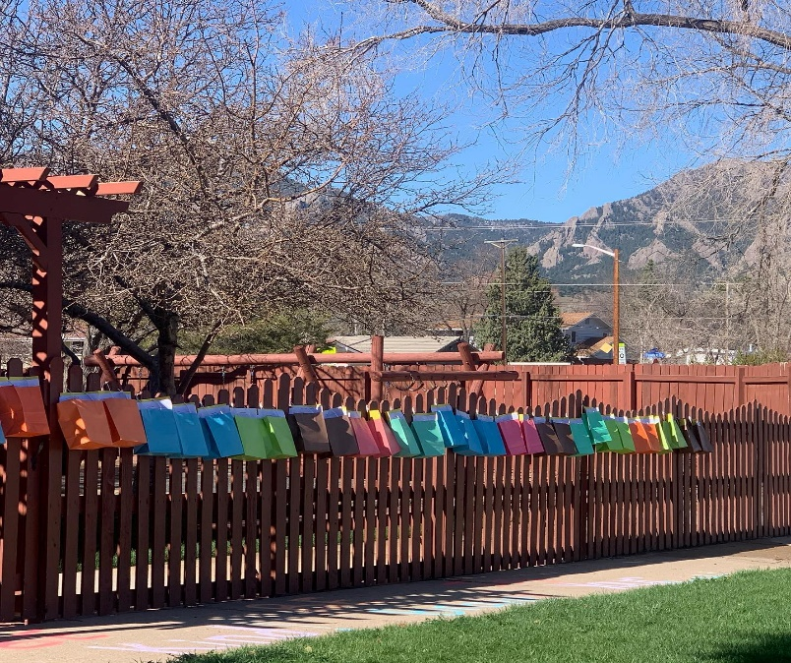
Enrollment includes:
- Weekly recorded stories.
- Weekly zoom music time.
- Take home activity bags:
  - Activities coordinate to
weekly story and theme.
  - Activities include: art, science, math, fine motor, sensory and literacy.
- “Handwriting Without Tears” for Preschool.
- BiWeekly zoom art lessons.
Cost: $25/week. Activities to be offered weekly following in person learning calendar
For more information Email: mtviewboulder@outlook.com
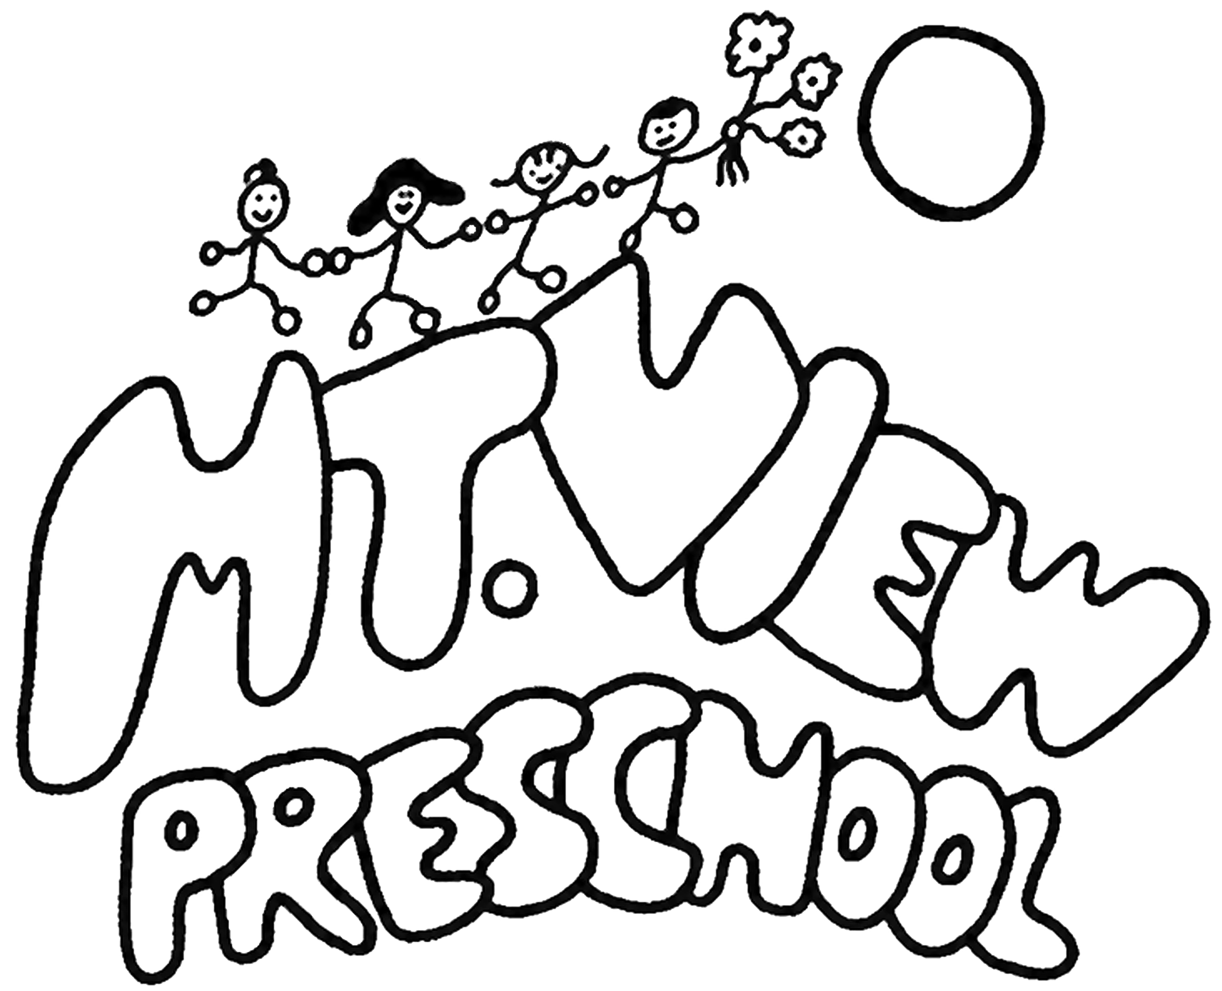

“At Home with Mt.View” Program Application

Child’s Name: ____________________________________________________ DOB: ________________

Parents’ Names: _______________________________________________________________________

Address: ___________________________________________ City/Zip: ___________________________

Phone: ___________________________ Email: ______________________________________________

My child regularly attends Preschool:__________________________________________(name of center).

Is your child ok to receive small pieces (less than 1 inch diameter) in the activity bags? ____yes _____no

Parents must agree to retrieve activity bags from Mt.View Preschool, 355 Ponca Place, Boulder Colorado.
Bags will be available weekly and will be provided at a determined location on premise that encourages social distancing. Adults other than teachers and staff are not permitted in the school building or on the playground during COVID restrictions. Please wear a mask when retrieving your child’s activity bag.

Cost of program: $25/week.

Parents commit on a month to month basis.
Commitment may be 1 – 9 months (September – May).

Enrollment will be complete when application is completed and returned with payment to:
(mailing address)
Mt. View Preschool
4800 Baseline Rd.
E104 #288
Boulder,CO 80303

(Parent’s Signature) (Date)

